Student Satisfaction with Online Course Delivery at University of Charleston

Melissa Farrish

Survey Report submitted for
EDF 711 Survey Research in Education
at Marshall University
in partial fulfillment of the requirements
for the degree of

Doctor of Education
in
Curriculum and Instruction

Dr. Ron Childress and Dr. Brenda Tuckwiller
Graduate School of Education and Professional Development

South Charleston, West Virginia
2013

Keywords: online learning, student satisfaction
Copyright 2013 Melissa Farrish

Abstract
As the University of Charleston prepares to continue the online learning modality established by Mountain State University, it is imperative to gauge the level of student satisfaction. The purpose of this survey was to determine how satisfied participants were with their online learning experience at University of Charleston. The survey results will provide valuable information to be considered by faculty and online course designers as student service processes are created and online courses are developed. Overall, students are satisfied with their online learning experience at UC. The key points identified by the survey are the importance of communication and the integration of audio and video in online course design.

Table of Contents
Abstract ii
Introduction 1
Methods 2
Type 2
Delimitations 2
Limitations 2
Target Population 3
Instrument 3
Validity and Reliability 4
Data Collection Process 4
Findings 5
Description of Respondents 5
Findings by Question 6
How satisfied are students with online courses at UC? 6
How satisfied are online students with student services at UC? 10
How can online course design and delivery be improved at UC? 11
Conclusions 13
How satisfied are students with online courses at UC? 13
How satisfied are online students with student services at UC? 13
How can online course design and delivery be improved at UC? 13
Discussion/Implications/Recommendations 14
References 15
Appendices 16

Student Satisfaction with Online Course Delivery at University of Charleston

Introduction
The Higher Learning Commission approved a complete takeover of Mountain State University by the University of Charleston in December 2012. Mountain State University served nearly 8,000 students with approximately 70% enrolled in online courses prior to being placed on “show cause” by the Higher Learning Commission. With little experience in online learning, the University of Charleston plans to continue the online modality established by Mountain State University.
The purpose of the survey was to determine how satisfied participants were with their online learning experience at University of Charleston. The survey results will be considered by faculty and online course designers as courses are developed for the summer and fall terms.
This is an ideal time to rethink online course delivery as the teach-out of Mountain State University courses in the Blackboard course management system (CMS) will end with the spring 2013 semester. The University of Charleston selected Moodle as the CMS beginning with the summer 2013 semester. Courses in the University of Charleston curriculum are currently under development for the summer term.
A survey was designed to obtain data to answer the following questions:
- How satisfied are students with online courses at UC?
- How satisfied are online students with student services at UC?
- How can online course design and delivery be improved at UC?

Methods

Type
A one-shot survey was chosen as the information-collection method. As Fink (2009) explains, “surveys can be used in deciding policy or in planning and evaluating programs and conducting research when the information you need should come directly from people” (p. 4). The data obtained from the survey describes feelings and perceptions on online course delivery at University of Charleston.
Participants utilized Survey Monkey for the online self-administered questionnaire. The online format made it possible to survey a large number of students from different geographic regions, time zones, and with different schedules. Students accessed the survey with a link provided in an announcement within Blackboard. Online self-administered surveys allow information to be obtained immediately, allow reminders to be easily sent to students, and data to be easily downloaded in a spreadsheet for data analysis. Since all participants are enrolled in online courses, they all have a level of computer literacy and many have completed online course evaluation surveys.

Delimitations
Course delivery method was a delimitation in this research. Only students currently enrolled in at least one online course during the 2nd 8-week session of the spring 2013 term were selected to participate in the survey.

Limitations
As a self-report survey, the responses are subject to the respondents. Self-report data is limited as it can be influenced by the respondents. The wording of questions may have impacted the ability to gain accurate responses. Inaccurate self-reporting can be caused by recall bias or errors in observation.
As a limitation, the survey link was provided using the announcements tool in Blackboard. Announcements appear under the notifications tab requiring students to click on the notifications tab to review announcements. Students may not be familiar with the notifications tab or take the time to read announcements.

Target Population
The population includes students enrolled in online courses at University of Charleston. The target population includes 402 students currently enrolled in at least one online course during the 2nd 8-week session of the spring 2013 term. Only students 18 years of age or older were permitted to participate in the study.

Instrument
A survey instrument (Appendix A) was developed in Survey Monkey. Survey questions included forced-response choices and open-ended questions.
Open-ended questions were utilized to gather opinions of what aspects of online courses made learning easier and more difficult for students. The final survey question asked for suggestions for improvement of online course design and delivery.
Ordinal scales with four choices, forcing respondents away from the middle ground, were used throughout the survey. Likert-type scales allowed participants to express how closely they agreed or disagreed with statements. Drop-down lists collected how many online courses students were completing this semester. The survey was reviewed by two University professors and University of Charleston online faculty to ensure clarity of language and instructions.

Validity and Reliability
Reliability is strengthened by the well-worded questions and instructions provided in the instrument. To increase the validity, clear questions were written and designed to obtain the information needed to assess student satisfaction. The survey has external validity as the findings are applicable to other institutions of higher education offering online course delivery.

Data Collection Process
Permission for the study was obtained from University of Charleston’s Institutional Review Board (see Appendix B). The study and informed consent were granted Exempted approval by the Marshall University Institutional Review Board on March 6th, 2013 (see Appendix C).
University of Charleston’s Director of Online Course Design placed an announcement requesting participation in the student satisfaction survey in all courses utilizing Blackboard on Monday, March 18th, 2013. The announcement included the informed consent (see Appendix D) and provided a link for the survey. An email from the Director to faculty explained a link was placed in their spring courses for a survey being conducted by a School of Business faculty member. The Director is well-known and respected by online faculty. The email further explained the survey did not replace the regular course/instructor end of term evaluation. Faculty were asked to help collect research data by encouraging students to participate in the survey.
By March 31st, 27 responses had been received. With the low response rate, the survey was extended through Sunday, April 14th with 61 responses. By Monday, April 15th, an additional three students completed the survey for a total of 64 responses. The survey was closed on Monday, April 15th.

Findings

Description of Respondents
All students enrolled in at least one online course were eligible to participate in the survey. Since the survey link was provided to students through the online course management system, Blackboard, only eligible students were able to participate.
The response rate was 15.9% with 64 of 402 students completing the survey. Incentives were not used.
According to Figure 1, students are carrying heavy loads with the majority of students enrolled in four online courses this semester.
Figure 1
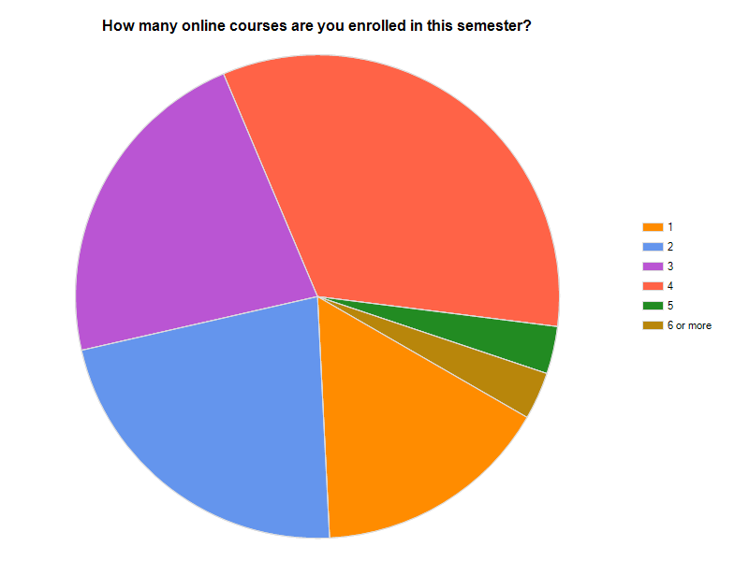
Figure 1: Number of courses in which students are currently enrolled from Survey Monkey.
As shown in Figure 2, students primarily choose online learning to accommodate work schedules, driving distance, and family commitments.
Figure 2
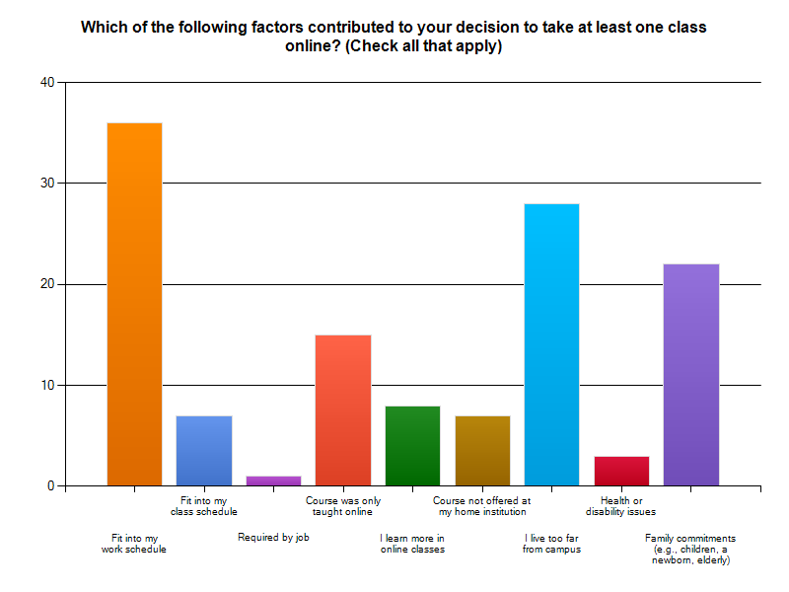
Figure 2: Factors contributing to the decision to enroll in online courses from Survey Monkey.

Findings by Question

How satisfied are students with online courses at UC?
Of the students who were not graduating, 33 of 38 students intend to enroll in online courses within the next year.

Figure 3
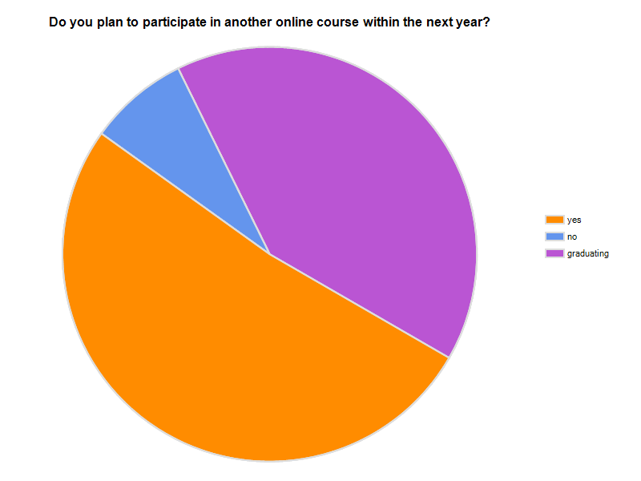
Figure 3: Student’s Future Intent to Enroll in Online Courses from Survey Monkey
Nearly 86% of students were satisfied or very satisfied with online courses at UC.
Figure 4
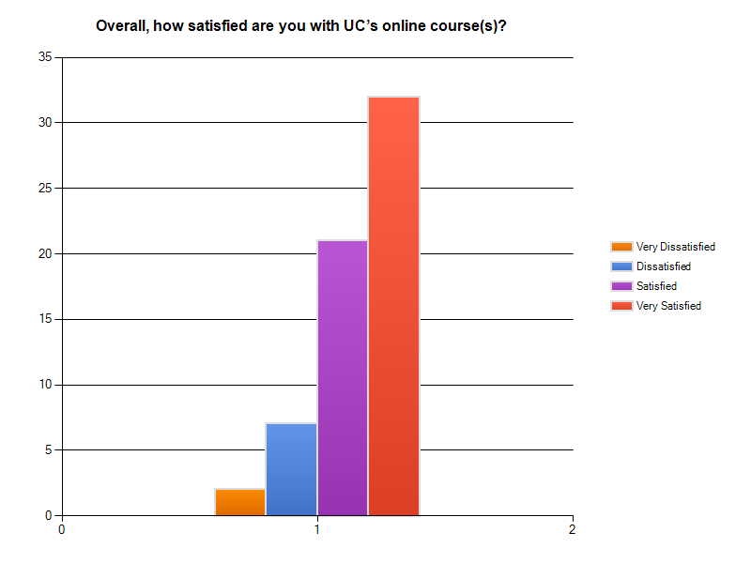
Figure 4: Satisfaction with Online Courses at UC from Survey Monkey

As shown in Figure 5, students are satisfied with the online interaction with the instructor and other students.
Figure 5
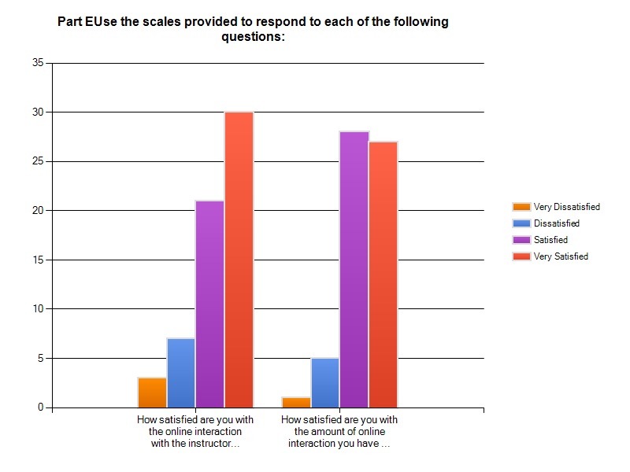
Figure 5: Satisfaction with Online Interaction from Survey Monkey

Over 85% of students would recommend UC’s online courses to their best friend.
Figure 6
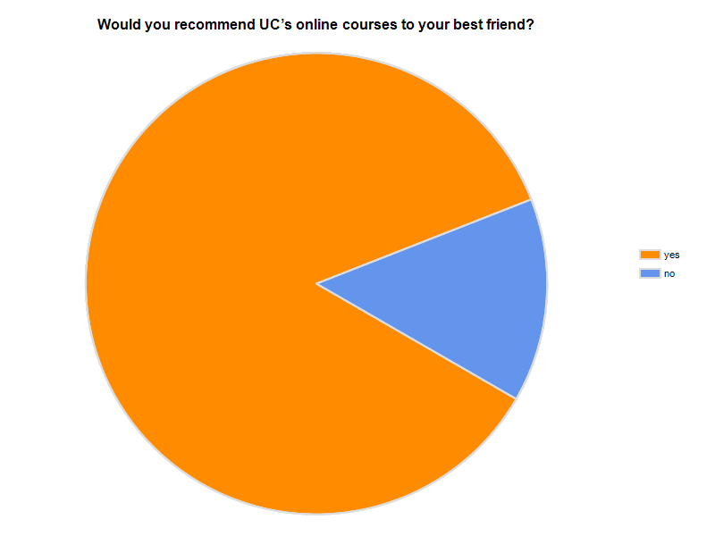
Figure 6: Recommendation of UC Courses to Best Friend
The students who would not recommend UC courses to their best friend made the following comments:
- Lack of communication with instructors and staff. Instructors do not respond to emails.
- Tutors are not available.
- Difficulty learning difficult material.
- Lack of chats or taped lectures to aid in learning.
After an evaluation of the characteristics of the online learning environment, students rated low marks for the quality of communication between instructor and students and the ability of online courses to aid in learning complex material.

Figure 7
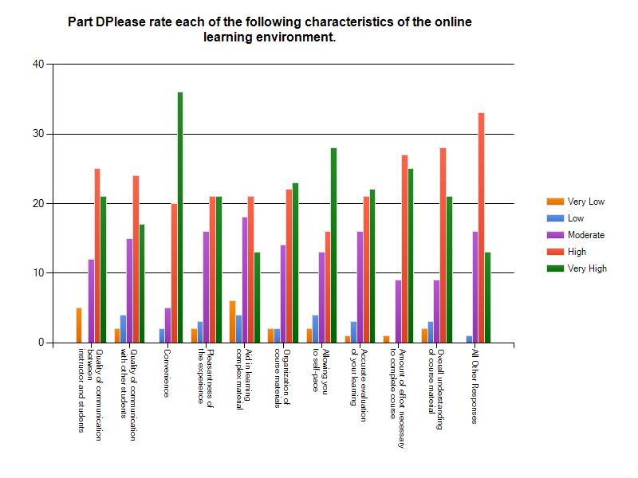
Figure 7: Rating of the Characteristics of the Online Learning Environment
The aspects of online courses which made learning easier for students include:
- Ability to self-pace
- Convenience
- Interaction with classmates

How satisfied are online students with student services at UC?
Overall, students are satisfied with student services at UC. The quality and accessibility of academic advising received a larger percentage of low and very low scores.

Figure 8
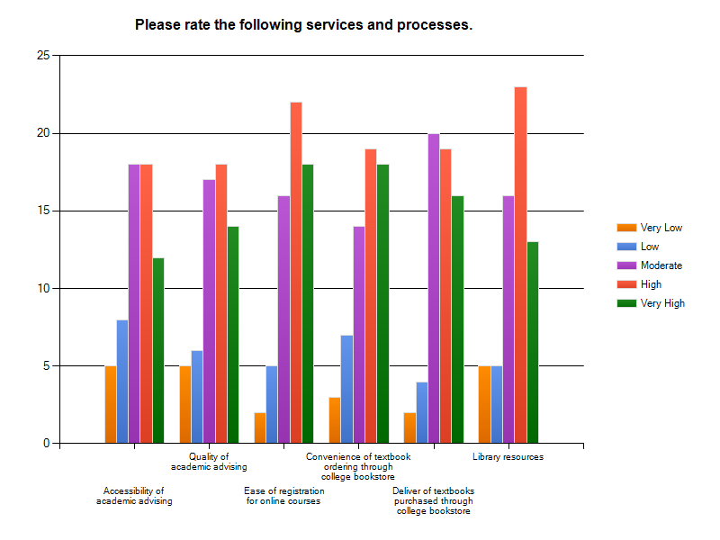

Figure 8: Rating of Services and Processes from Survey Monkey

How can online course design and delivery be improved at UC?
A total of 53 students provided suggestions on how online course design and delivery can be improved at University of Charleston. The most common themes were:
- Utilize video and audio for lectures
- Timely and useful feedback
- Timely response to emails

Students report how frequently a variety of online tools were utilized in online courses. Figure 9 shows many tools are not used at all.
Figure 9
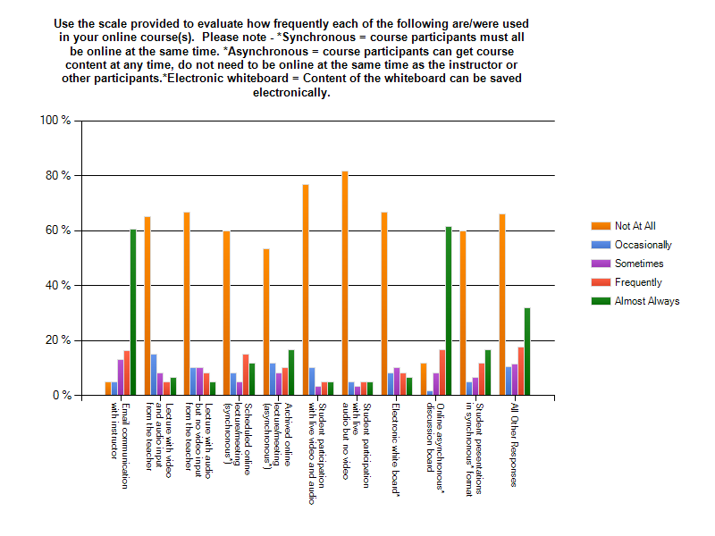
Figure 9: Online Tools Frequency of Use
The aspects of online courses which made learning more difficult include the following:
- Ability to understand difficult subject matter
- Timed exams
- Students not actively participating in discussions
- Lack of face-to-face interaction with instructor and classmates
- Lack of lectures
- Lack of communication
- Lack of feedback on assignments and exams
Appendix E provides a summary of each question with the responses.

Conclusions

How satisfied are students with online courses at UC?
Overall, students are satisfied with online courses at UC. The majority of students intend to register for additional online courses and would recommend UC’s online courses to their best friend.

How satisfied are online students with student services at UC?
Students are satisfied with many of the student services available to online students. Academic advising received lower scores. Student services keep students connected to the University as the majority of online students live at a distance.

How can online course design and delivery be improved at UC?
Most of the suggestions offered by students followed three main themes. Students would like to see video and audio components added to the course. Many students commented they had difficulty with complex material in the online delivery format.
Effective communication is an integral component of effective online course delivery. Instructors should provide feedback which is specific, timely, and useful to students. Faculty must provide prompt responses to student emails.
Tools within the course management system including synchronous chats, video, audio, are not being utilized by many faculty.

Discussion/Implications/Recommendations
Students are carrying a heavy course load while juggling work, family, and school commitments. Online learning makes learning convenient and accessible for these students by reducing geographic and time constraints.
It is recommended academic advising staff receive training to increase the quality of academic advising. New processes are needed to increase accessibility to academic advising services.
It is recommended UC incorporate video and audio components which would allow instructors to provide lectures with visual aids to assist students with difficult concepts. Primarily with the quantitative courses, video and audio components could enhance the learning experience and provide instruction for students with various learning styles.
Faculty should make prompt and effective communication a priority. UC requires faculty to respond to student inquiries within 48 hours. This turnaround is not helpful to a student with a question posed on a weekend when the assignment is due on Sunday. Faculty should be encouraged to maintain an active presence within the online classroom.
It is recommended UC provide intensive training on Moodle, to ensure faculty have a clear understanding of the tools available within the course management system. When used effectively, these tools can enhance the educational experience of students enrolled in online courses.
The online learning modality clearly provides educational opportunities to many students. Incorporating the suggestions provided by students will enhance online learning at University of Charleston leading to greater satisfaction.

References
Fink, A. (2009) How to Conduct Surveys: A Step-by-Step Guide.
Thousand Oaks, CA, Sage Publications, Inc.

Appendices

